# ‘Real’ and ‘Faux’ Chiptune

Student ID: SLA21080662

## Introduction

Digital Music has always followed closely behind many technological advances in hardware and software, with some genres becoming defined by the state of the technology at the time, ‘Chiptune’ music is one of the best examples of this. Chiptune (or Chiptunes) are by definition ‘songs made on the sound chip of a game console’ (The 8-Bit Guy, 2015) which can be found dating back from as early as the 1980’s. Prior to this, game consoles had no dedicated sound chip and required consoles CPU to process every aspect of the game; meaning there would be very little memory programmers could dedicate to music or sound effects which in turn led to an era of classic games that were either silent or only produced simple sound effects (McDonald, 2005). However, beyond this is where the artform of chiptune really began to develop, newer consoles would allow for sound chips with more memory, which would allow the programmers to begin to be show their creativity through the use of them. Modern day practitioners of Chiptune vary in styles across the eras of chiptune that were dictated by what the sound chips were capable of at the time, and despite modern technology no longer having many of the restrictions the original consoles did, a lot of the music is reminiscent of the aesthetics that came from techniques used to maximise the performance of these chips. Though Chiptune is traditionally any song made using a classic game consoles hardware, modern Chiptune is a culmination of a variety of styles, genres, and aesthetics tied together by technology. Carlsson (2014) drew connections between the Chiptune genre and the Folk genre, pointing out that both are embodiments of large cultures of music that is hard to give an exact description of “*Folk music is almost as hard to define as Chipmusic is. You have a feeling you know what it is, but if you start to explain it you’ll run into trouble quite easily*”. The average listener may find it difficult to distinguish between styles of chiptune, but when one looks deeper into the matter they will notice that modern chiptune is derivative of certain eras, technology within consoles, and writing approaches that arose from technical restrictions which can be emulated or authentically programmed using the original technology. Emulated Chiptune often gets denoted as ‘Fake’ or ‘Faux’ Chiptune (Quillfeldt, 2019), and I am going to explore the reasoning behind this and arguments for either combining or distinguishing the styles of Chiptune production.

## The Origins of ‘Chiptune’

In order to understand the more contemporary discourse around Chiptune, it is important to understand its history and how it became what it is today.

Before game consoles had sound chips, dating back to arcade era of video games, consoles could only make sounds through the use of internal ‘Speaker beepers’, these sounds were simplistic and very sparingly used as they took a lot of CPU capacity to even generate these (The 8-Bit Guy, 2015).

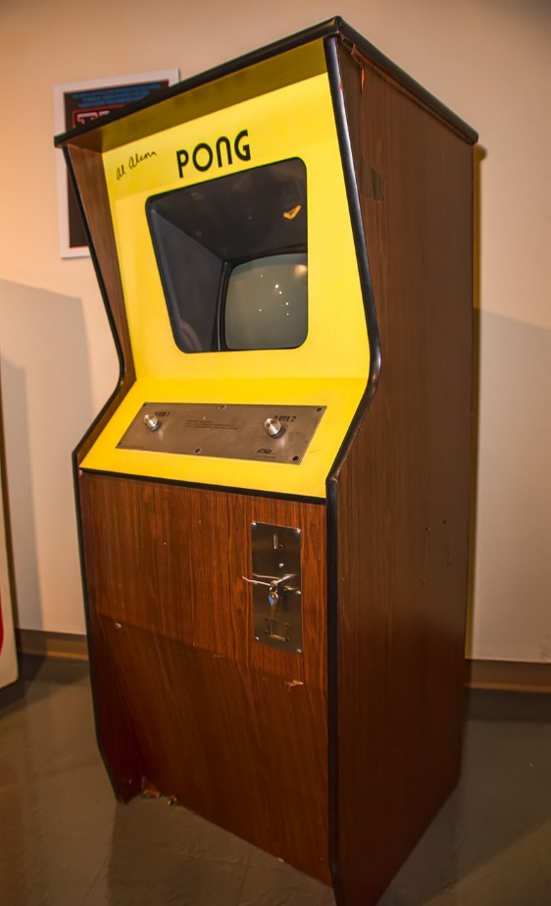Developed by Atari and released in 1972, ‘Pong’ was the first video game to make use of this for sound effects. The CPU would generate a ‘sonar-blip’ noise to emulate the sound of the digital ping pong ball hitting the player-controlled paddles, and for such a simple game it is obvious through the sheer size of the cabinet how much processing power was required to achieve even this (McDonald, 2005).

Though this is nowhere near reminiscent of anything one would consider Chiptune, it marked the starting point for the development of the technology which would allow Chiptune to emerge.

*[1] An original ‘Pong’ arcade cabinet, 1972 (Wikipedia, n.d.)*

### FM Synthesis

Jumping forward to 1980, video game consoles were beginning to be developed with a built-in sound chip that would take processing load from the CPU and allow for more complex sound design to be created. One such tool which came from this new advanced hardware was ‘FM Synthesis’ Frequency Modulation (FM) is a technique where simple waveforms are compiled to change the overall pitch and tone of the sound produced over time, this is done by using ‘modulator’ waves to alter a ‘carrier’ wave, as pictured below:

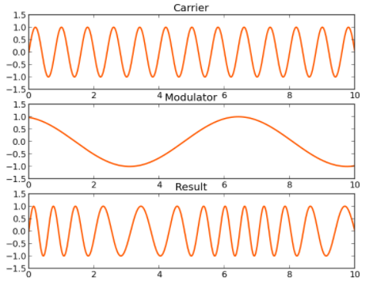

*[2] Visualised FM Synthesis, as the modulator waves becomes positive the carrier wave’s frequency increases (Cymatics, 2022)*

In more modern terms, the ‘Modulator’ wave can be viewed as a ‘Low Frequency Oscillator’ (LFO) which has the job of altering the audible ‘Carrier’ wave using a low frequency wave inaudible to human ears (Deniel, 2019). Multiple different waves, or even audible waves, can be used to modulate a carrier wave which would result in changing the overall tone of the sound in a more drastic way, demonstrated in [this](https://youtu.be/vvBl3YUBUyY?t=100) [3] video (Huang, 2018).

Using these techniques, a large variety of sounds could be produced through FM synthesis on these new sound chips. Consoles such as the Nintendo Entertainment System (NES) and Commodore 64 were early adopters of this new technology, and both yielded different results in their approach to sound design. The NES had five voices, meaning it could play 5 sounds at once which covered both the music and sound effects, but these sounds were limited in certain ways. The first two voices could only produce ‘Square’ waves, the third produced a ‘Triangle’ wave, the fourth produced a static noise, and the fifth was reserved for sampled noises (The 8-bit guy, 2015). This meant that if you wanted two triangle waves to play at the same time it would be impossible since theres only one voice for it. An interesting detail about the NES is that it shared almost the exact same hardware as Nintendo’s later released ‘Famicom’ console, but the Famicom’s hardware was arranged in such a way that allowed game cartridges to make use of extra connector pins inside the console (1morecastle, 2014). This meant that developers could implement more ‘voices’ to play sounds on Famicom versions of games compared to NES, resulting in situations where the exact same game could have multiple versions of a soundtrack which make use of a higher voice count, such as [CastleVania III](https://youtu.be/14rPeAy6gDA) [4]. The Commodore 64 on the other hand has a much more freeform approach to voicing, despite only having three voices in total each voice could play anything from square, triangle, sawtooth, and static noise. While on paper this may seem much more limiting when compared to the five voices the NES could play, it allowed artists to program multiple music lines into one voice and give the illusion of having more voices play than there was, which is visualised for the 1989 game ‘Time Trax’ [here](https://youtu.be/MozqL_HkHF4) [5] (The 8-bit guy, 2015).

The creativity required to write and program songs with such limited number of voices led to define one of the key characteristics of Chiptune music: clarity of musical ideas. When one thinks of Chipmusic, it’s hard not to imagine the catchy melodies in games such as Super Mario Bros or The Legend of Zelda, and I am of the opinion that these arose through very talented artists making the absolute most of what little sounds they had to work with. Each voice line had to be succinct and to the point, as there was very little room to spread musical ideas out over multiple voices since it would take too much memory. Only when the hardware allowed it did artists take advantage of the technology and aim to fill out their music more (as demonstrated in the [CastleVania III](https://youtu.be/14rPeAy6gDA) [4] soundtrack). Though clever coding techniques could be utilised to do more with the music, such as writing both the drums and base of a song into one voice, the majority of music that went on to influence the next generation of Chiptune were songs with memorable melodies and a fairly limited musical palette.

### PCM Sampling

Before discussing modern Chiptune there is another important aspect of it that goes relatively unrecognised when compared to FM Synthesis: Pulse Code Modulation (PCM) Sampling.

*[6] Casio SK-1 Sampling Keyboard 1985 (Wikipedia, n.d.)*

Around the same time as FM Synthesis was introduced, PCM sampling was the feature present in a large number of sound chips, such as the NES, which allowed short samples to be taken and implemented as a voice in sound effects and songs (The 8-bit guy, 2015). It is worth noting that while this feature was also becoming more popular with the general public at the same time, such as with the introduction of the affordable ‘Casio SK-1’ sampling keyboard (pictured above) that allowed users to make 8-bit recordings up to 1.4 seconds long (Friedman, 2008), PCM Sampling was particularly popular with the Chiptune scene at the time. It allowed artists to insert external samples into their music while controlling how much memory the sample would take, an important feature when there was very little expendable memory in these earlier consoles. A good example of this is the theme from ‘Blood Money’ which was released for the Commodore Amiga in 1987, found [here](https://youtu.be/mUVSX9L6f3I) [7]. The less memory the sample took, the lower the sample rate needed to be, which introduced a lot of distortion into them and turned sampling into a balancing act between quality and memory (GST Channel, 2017), noticeable in the ‘Blood money’ theme [7], which even required a separate disc just to run the intro music and video despite low quality. Some might find this an undesirable feature, but like the crackle on vinyl records, it also has a sort of unique charm that has driven people to emulate it in the modern day. An example being music made for the ‘MIDI’ or ‘Sequencer’ scenes (such as ‘BIG SHOT’ from the 2021 game ‘Deltarune: Chapter 2’, found [here](https://youtu.be/uivFFnCI8tM) [8]); which brings us to the next topic of discussion: MIDI.

### MIDI Libraries and Soundfonts

‘Musical Instrument Digital Interface’ (MIDI) was invented in 1981 (MIDI Association, 2021) to allow different instruments and interfaces to easily communicate with each other as well as computers (LANDR, 2020), which became popular in the video game music scene not long after PCM sampling. It gave video game music artists the option to import premade samples and sounds into their projects using the sound bank provided by the sound chip in a console or PC (GST Channel, 2021), reducing the need to use custom PCM samples or FM Synthesis. Many higher budget games still made custom libraries to use in games unique to their title, but for lower budget games it was cheaper and easier to implement general midi (GM) soundsets, such as the original ‘Roland GM Soundset’ or the ‘Microsoft Disc Operating System’ (MS-DOS) GM Soundset (GST Channel, 2021). The intention behind this was to reduce the amount of computer programming needed to be able to write music for a console, but in its unstandardised form it led to very mixed results when the music was ported between consoles that had different sound chips with different preset midi libraries. Originally, different sound chips would assign a specific sound to a number, for example number ‘1’ might be a guitar on one console, but instead might be a trumpet on another, meaning if a song was ported to a chip it wasn’t wrote one it may sound completely different to what was intended (GST Channel, 2021) – such as the infamous ‘Mansion Basement’ theme from ‘Resident Evil Director’s Cut’ (1996), found [here](https://youtu.be/iJYvCHm3Ov4) [9]. This was only a temporary issue however, as certain companies solved this by creating standardised editors for porting games to their consoles, such as Sega’s ‘Genesis Editor for Music and Sound Effects’ (GEMS) (pictured below). This editor let artists translate their midi data into a readable sequence by the console to ensure it sounded how it was intended to (GST Channel, 2017).

*[10] GEMS interface (Tha Sega Freak, 2014)*

While a lot of artists found general MIDI sound sets easier to implement than programming music, it also reduced individuality in a lot of game soundtracks at the time since they would all use the exact same sounds. While these GM libraries are still popular to sample in ‘MIDI’ or ‘Sequencer’ scenes, they are on par with MIDI libraries created for certain games which gain a heightened status in the Chiptune community, for example the game ‘Final Fantasy VII’ (1997) and the samples used in music such as ‘One Winged Angel’, found [here](https://youtu.be/A4UDSVTNL3M) [11]. In more modern terms, creating a song using the same midi library as a specific GM Soundset or a midi library unique to a specific game or franchise would be understood as using a ‘Soundfont’, and this is where the divide between what is considered ‘Chiptune’ and what is not becomes blurry. Despite the fact that the music is still made on console sound chips, the vast majority of the modern public wouldn’t consider most MIDI library music Chiptune, this is because instead of focusing on 8-bit FM synthesis it focuses on 16-bit sampling synthesis and emulating real instruments rather than electronic sounds. This divide is present in the fact that MIDI or Sequencer is usually listed as either a separate genre or a sub-genre of Chiptune on popular music sites, such as ‘Rate Your Music’ (2022) (RYM), though this also raises the idea of modern Chiptune becoming more of a blanket genre rather than a single genre itself. Some artists would even consider Chiptune an “instrument” rather than a genre (Giovanni, 2020), which is where some of the topics of discussion in modern Chiptune begin to arise, can something really be considered Chiptune if it was not made on the correct instrument/console, how elaborate can Chiptune be before it simply becomes Electronic music? The answers are ambiguous and varied but by taking a look at the modern Chiptune scene we can begin to understand the discourse surrounding it.

## Modern Day Chiptune

### My own practise

Before discussing the discourse in various scenes of modern Chiptune, it is important to provide context around my own musical background to allow me to compare the scenes to my own practice. At the time of writing, my style of music involves Chiptune, MIDI, and acoustic fusion heavily inspired by modern video game soundtracks, I consider UNDERTALE (2015) to be my biggest influence compositionally. The UNDERTALE soundtrack is heavily influenced by the Super Nintendo Entertainment System (SNES) era of music, which shows through the usage of classic MIDI Soundfonts and basic synths emulating the FM synthesis available on the console, an example song of the soundtrack ‘Spider Dance’ can be found [here](https://youtu.be/NH-GAwLAO30) [12]. The production in many of the songs make use of simple effects, such as a short delays or bit-crushers to emulate low fidelity PCM sampling, which are faithful to the SNES era, but it also takes advantage of the fact that it isn’t limited by any console hardware. It does this by seamlessly blending in higher fidelity sounds or acoustic samples which wouldn’t have been possible on the SNES, which is a feature of this and many other soundtracks I took inspiration from when making my own music. My earlier music was more sincere to the MIDI and Chiptune scene, mostly since preset MIDI and synths are cheaper and easier to implement than to record realistic instruments or learn to design my own synths. This approach both helped me slowly learn to use more complex methods of music production, and bolstered my love for the genre and simpler soundscapes you can create with these tools, such as by blending basic synths with MIDI guitar and percussion samples in my song ‘Tropical Breeze’ (2020), found [here](https://obstagoon.bandcamp.com/track/tropical-breeze) [13]. However, as I’ve grown as a musician and learned to produce my own synths and edit more realistic instruments, a scene which has heavily intrigued me is ‘Digital Fusion’. First coined by the musicians Aivi Tran and Surasshu Velema in 2020, Digital Fusion is *“music that combines various musical genres with early PC/computer music styles that were shaped by hardware limitations…where composers have adopted their vernacular without their original hardware limitations”* (Tran & Velema, 2020). Aivi and Surasshu also worked on a Digital Fusion album called ‘The Black Box’, which combines live piano recordings with emulated Gameboy FM synthesis to become a perfect example of the Digital Fusion genre, such as in the song ‘Shapeshifter’, found [here](https://youtu.be/4R9oLpywSrw) [14]. This album was very influential to me and also inspired me to fuse Chiptune with various genres and styles of music, my song ‘Repose’ (found [here](https://obstagoon.bandcamp.com/track/repose) [15]) makes use of minimally and heavily edited live instruments, basic and advanced synthesis, and MIDI sounds to create a song that I find hard to fit into one genre, but I believe epitomises my own approach to the fusion of modern and old technology.

Even when fused with other production approaches, the way Chiptune is created has a large impact on how many people would perceive the music. There is a lot of discourse around what can be considered authentic Chiptune and what is known as ‘Faux Chiptune’, which leads to the topic of emulation and replication in modern Chiptune.

### Authentic Replication vs Emulation

Since old technology has passed and new plugins and hardware make creating Chiptune a lot simpler than it originally was, many artists (including myself) choose to design synths and sound effects in more modern ways which emulate a similar sound to how the original technology on older consoles would create Chiptune. However, despite how similarly emulated the modern Chiptune may be, many practitioners of the genre, found all over the internet from message boards (Synth Studio, 2011; Reddit, 2020) to professional interviews (Raine, 2018), distinguish between ‘real’ Chiptune and ‘fake’ Chiptune. Also known as ‘Faux’ or ‘Post’ Chiptune (Quillfeldt, 2019), any music which takes from the Chiptune aesthetic but does not use authentic methods of achieving it may be labelled differently to authentic Chiptune. In some ways, the need to distinguish between authentic and emulated Chiptune is understandable, authentic recreation is much more akin to computer programming than composition and the level of effort and mastery presented in authentic replication may get undermined by an emulation achieving the same thing. But often they go undistinguished by the average listener, especially when emulated well enough that it is hard to differentiate between ‘real’ or ‘fake’ Chiptune without obvious fusions of higher fidelity sounds, such as in my song ‘BugQuest’ (2020) which blends emulated Chiptune with acoustic piano sound banks, found [here](https://obstagoon.bandcamp.com/track/bugquest) [16]. But it’s not entirely about the final product for many people, for a lot of Chiptune artists, technology is a major part of their culture, as pointed out by Tomczak, (2008): *“The unique sonic characteristics of the devices used and the way in which they are controlled form an integral part of the identity that is shared by many chiptune musicians and performers”*.

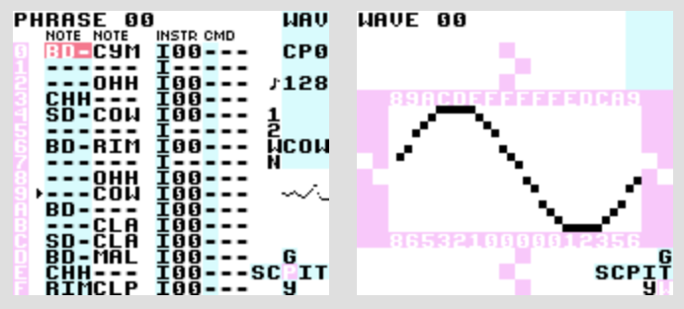

*[17] LSDJ interface (Little Sound DJ, n.d.)*

Pictured above is the interface for a Gameboy music program released in 2000 called ‘Little Sound DJ’ (LSDJ), which allows artists to insert a special cartridge into a Gameboy and authentically create tracker music using the Gameboys native hardware (Little Sound DJ, 2022). The Gameboy was famous for many classic soundtracks featuring four-voice polyphony, but until tools such as LSDJ or similar ones for other game consoles were created, the homebrew Chiptune community was largely separated from the traditional Electronic music scene (Driscoll & Diaz, 2009). Gameboys have a uniquely popular role in the Chiptune scene, which is considered by Márquez (2011) to be partly due to the accessibility of the handheld console, found in all corners of the world due to its popularity, and the nostalgia surrounding games released on the console for modern generations. They may also hold ‘symbolic strength’ for many who use it, allowing artists to sincerely recreate music in the way the genre rooted from while also presenting a very anti-consumerist stance. Through taking advantage of household products and fashioning them to become powerful music creation tools, it presents a strong ‘Do It Yourself’ message alongside similar elements of the scene, such as homemade merchandise, music distribution, event organising etc. (Tomczak, 2008). Some have compared these DIY sentiments in the Chiptune community to those in the ‘Punk’ community, it could be argued that the Chiptune scene shares similar political, social, and aesthetic beliefs to those that the Punk scene arose from, from anti-consumerist beliefs to ideas that the music produced must contain certain instruments to be considered ‘correct’ for the genre (Tomczak, 2008). And while poorly received by the Chiptune community at the time for believing it was only to raise unnecessary hype, even the former Sex Pistols manager Malcolm McLaren wrote an article for Wired Magazine which claimed “Chiptune music to be the new Punk” (McLaren, 2003).

Though I, and I assume many other artists, would love to engage with this side of the scene which involves more practical Chiptune creation, it is still more difficult to engage with authentic replication than it is to engage with emulation.

*[18]* *How musicians learn to create Chiptune (Stapleton, 2018)*

Stapleton (2018) interviewed 54 participants and coded their methods for learning to produce Chiptune over a number of techniques, ranging from the least popular methods by average: ‘Personal Communication’ and ‘Long Form Writing’, to the most popular by average: ‘Experiment with Tool’. While it is a small sample size, these results show a trend that most Chiptune practitioners are more likely to be self-taught through experimentation with any available tools than learn through other means. When considering the benefits of Chiptune emulation compared to authentic recreation when experimentation is the most popular method of education, it could be argued that Chiptune emulation is a better method for learning the genre due to the effort and cost of each approach. Tomczak (2008) lists a few benefits of Chiptune emulation compared to replication: it is more cost effective to emulate as it does not require any peripheral technology and can be easily integrated into any DAW, as opposed to requiring extra hardware to capture audio from authentic game consoles. In general, most emulation software is completely free to download, but it can be expensive to purchase a physical version of the same thing being emulated and would also require the musician to be familiar with a completely new music interface, which is not necessary in emulation since it runs off the DAW the artist is familiar with. In most cases, the want for authentic technology to create Chiptune is closely linked to nostalgia and live performance, the Chiptune scene is heavily tied to the DJing scene “except with original compositions instead of vinyl and 8-bit microprocessors instead of turntables” (Rose, 2011). Artists, such as Chipzel, perform entire shows through the use of a Gameboy running LSDJ with effects parameters linked to peripheral hardware to give the artist control (Keogh, 2015), and it is in this format that I believe the need to differentiate between Faux and Real Chiptune is most present.

However, is it not in the spirit of the genre to make the most of the hardware and software granted to you? Even in the prime days for Chiptune creation artists would take advantage of any extra processing power they could, as shown through the use of extra voice connectors when transferring soundtracks from the NES to the Famicom (1morecastle, 2014). The advancements of technology have allowed many more people access to what would have been a much more closed-off scene if owning the original hardware was a requirement, and I am of the opinion that in most cases it does not matter how the Chiptune was created, only that it is reminiscent of the origins of the genre, regardless of whether it is fused with other genres. Orchestral music can be created using sample packs and not entire orchestras out of ease and still be considered acceptable in the genre, of course the real instruments provide better quality, but it is not feasible all of the time for many artists; in my opinion similar can be said about Chiptune and owning the correct instruments: original game consoles. Exploring the history and modern discourse of Chiptune has helped me understand the key features of the genre and the sentiments shared by members of the community, I believe that the genre should not be locked behind the purchase of specific hardware and emulation should be accepted with open arms by more Chiptune artists, rather than shunned and relabelled as ‘faux’ or ‘fake’. Emulation has allowed me, and many other artists, to explore a rich genre of music, which I will forever be grateful for.

*4090 words*

## References

1morecastle. (2014) *Famicom vs NES.* Available at: <http://www.1morecastle.com/2014/05/famicom-nes/> (Accessed: 18 December 2021)

Carlsson, A. (2014) *Chip Folk Music.* Available at: <https://chipflip.wordpress.com/2014/04/14/chip-folk-music/> (Accessed: 27 December 2021)

Cymatics. (2022) *Sound Design Basics: FM Synthesis.* Available at: <https://cymatics.fm/blogs/production/fm-synthesis> (Accessed: 21 December 2021)

Deniel, M. (2019) *Analog vs FM Synthesis The Stunning Differences.* Available at: <https://www.popsonguniversity.com/3218-2> (Accessed 21 December 2021)

Driscoll, K., & Diaz, J. (2009). *Endless loop: A brief history of chiptunes*. Transformative Works and Cultures, 2(1).

Friedman, M. (2008) *Casio SK-1.* Available at: <https://www.vintagesynth.com/casio/sk1.php> (Accessed: 23 December 2021)

Garg, V. K. (2007). *An overview of wireless systems*. Wireless Communications Networking, Morgan Kaufmann, I st edition. Isbn, 123735807.

Giovanni, G. D. (2020) *Chiptune is an instrument not a genre: Square Sounds Festival 2020.* Available at: <https://www.sifter.com.au/post/chiptune-is-an-instrument-not-a-genre-square-sounds-festival-2020> (Accessed: 7 January 2022)

GST Channel. (2017) *How to make Sega Genesis music (in 1994).* Available at: <https://youtu.be/WEvnZRCW_qc> (Accessed: 15 December 2021)

GST Channel. (2021) *Niel Biggin Had an Antagonistic Relationship with MIDI.* Available at <https://youtu.be/R3VH9Mi03n0> (Accessed: 14 December 2021)

Huang, A. (2018) *FM SYNTHS in under 4 minutes.* Available at: <https://youtu.be/vvBl3YUBUyY> (Accessed: 21 December 2021)

Keogh, K., (2015) *Gameboy Beats and Liquid Geometry Glitch Rainbows? Welcome to Square Sounds Festival.* Vice. Available at: <https://www.vice.com/en/article/bmkzp8/gameboy-beats-and-liquid-geometry-glitch-rainbows-welcome-to-square-sounds-festival> (Accessed: 22 December 2021)

Rose, J. (2011) *Magical Game Boys: Demystifying The Live Chiptune Performance.* Available at: <https://www.vice.com/en/article/4xxndb/new-diy-game-boy-synth-will-bring-8-bit-to-the-masses> (Accessed: 22 December 2021)

LANDR. (2020) *What Is MIDI? How It Works and Why It’s Useful.* Available at: <https://youtu.be/9zFecOaD4CU> (Accessed: 15 December 2021)

Little Sound DJ. (2022) *Index*. Available at: <https://www.littlesounddj.com/lsd/index.php> (Accessed: 14 January 2022)

Márquez, I. (2011, Unpublished) *Israel V. Márquez interviews Domenico Quaranta*. Available at: <http://domenicoquaranta.com/public/TEXTS/2011_06_marquez_interview.pdf> (Accessed: 24 December 2021)

McDonald, G. (2005) *A History of Video Game Music.* Available at: <https://www.gamespot.com/articles/a-history-of-video-game-music/1100-6092391/> (Accessed: 20 December 2021)

McLaren, M. (2003) *8-Bit Punk*. Wired. Available at: <https://www.wired.com/2003/11/mclaren> (Accessed: 17 January 2022)

MIDI Association. (2021) *The History Of MIDI.* Available at: <https://www.midi.org/midi-articles/the-history-of-midi> (Accessed: 14 December 2021)

Quillfeldt, T. (2019) *What is Post-Chiptune?.* Laced Records. Available at: <https://www.lacedrecords.com/blogs/news/what-is-post-chiptune> (Accessed: 14 January 2022)

Raine, L. (2018) *A Little Bit About Celeste’s Synths (And Some Bonus Piano).* Medium. Available at: <https://medium.com/@kuraine/a-little-bit-about-celestes-synths-and-some-bonus-piano-461f62605ea1> (Accessed: 14 January 2022)

Reddit. (2020) *Can you make actual chiptune in a DAW?.* Available at: <https://www.reddit.com/r/chiptunes/comments/gyur48/can_you_make_actual_chiptune_in_a_daw/> (Accessed: 14 January 2022)

Sonemic, Inc. (2022) *Sequencer & Tracker.* Available at: <https://rateyourmusic.com/genre/sequencer-and-tracker/> (Accessed: 4 January 2022)

Stapleton, J. M. (2018). *Music making, teaching, and learning in Chiptune communities*. The Computer Games Journal.

Synth Studio. (2011) *Faux Chiptune Music?.* Available at: <http://www.synth-studio.com/blog/audio-music/fauxchiptunes/> (Accessed: 14 January 2022)

The 8-bit guy. (2015) *How Oldschool Sound/Music worked.* Available at: <https://youtu.be/q_3d1x2VPxk> (Accessed: 20 December 2021)

Tomczak, S. (2008). *Authenticity and emulation: Chiptune in the early twenty-first century*. ICMC.

Tran, A., Velema, S. (2020) *Digital Fusion.* Available at: <https://www.digifumusic.com/> (Accessed: 20 October 2021)

## Bibliography

[1]

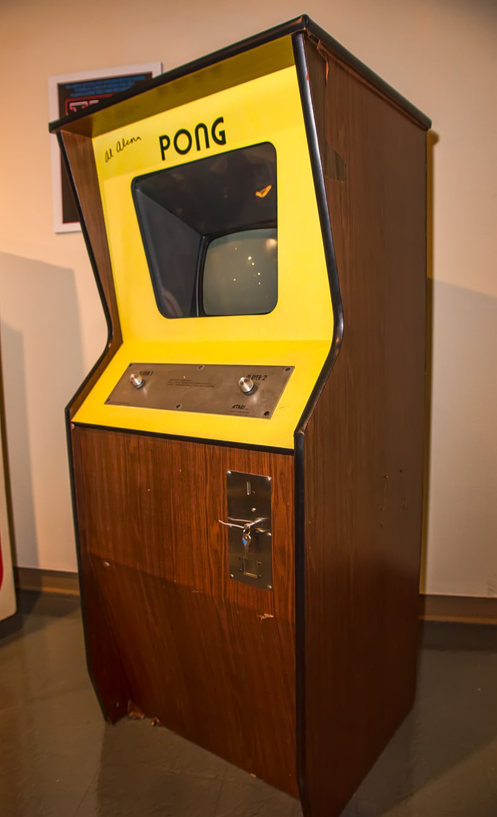

[An original ‘Pong’ arcade cabinet, 1972]

Wikipedia. (n.d.) *Pong.* Available at: <https://en.wikipedia.org/wiki/Pong#/media/File:Signed_Pong_Cabinet.jpg> (Accessed: 14 December 2021)

[2]



[Visualised FM Synthesis]

Cymatics. (2022) *Sound Design Basics: FM Synthesis.* Available at: <https://cymatics.fm/blogs/production/fm-synthesis> (Accessed: 21 December 2021)

[3] Huang, A. (2018) *FM SYNTHS in under 4 minutes.* Available at: <https://youtu.be/vvBl3YUBUyY> (Accessed: 21 December 2021)

[4] indask8. (2008) *Castlevania III Nes VS Famicom Music.* Available at:<https://youtu.be/14rPeAy6gDA> (Accessed: 4 January 2022)

[5] Flygon. (2016) *Sega Mega Drive/Genesis “Time Trax – Complete Soundtrack” by Tim Follin Oscilloscope View.* Available at: <https://youtu.be/MozqL_HkHF4> (Accessed: 18 December 2021)

[6]

[Casio SK-1 Sampling Keyboard 1985]

Wikipedia. (n.d.) *Casio SK-1.* Available at: <https://en.wikipedia.org/wiki/Casio_SK-1#/media/File:Casio_SK-1.jpg> (Accessed: 14 December 2022)

[7] blogfiles. (2011) *Blood Money – full length intro music clip.* Available at:<https://youtu.be/mUVSX9L6f3I> (Accessed: 5 December 2021)

[8] Toby Fox. (2021) *BIG SHOT.* Available at: <https://youtu.be/uivFFnCI8tM> (Accessed: 4 December 2021)

[9] Aidan’s Thing. (2021) *Resident Evil Director’s Cut DualShock OST – Mansion Basement (Reupload).* Available at: <https://youtu.be/iJYvCHm3Ov4> (Accessed: 4 December 2021)

[GEMS Interface]

Tha Sega Freak. (2014) *GEMS (Genesis Editor for Music and Sound Effects).* Available at: <https://thasegafreak.wordpress.com/2014/08/08/gems-genesis-editor-for-music-and-sound-effects/> (Accessed: 20 December 2021)

[11] Pankratous. (2011) *[FFVII] One Winged Angel – [HD]*. Available at: <https://youtu.be/A4UDSVTNL3M> (Accessed: 8 January 2022)

[12] Toby Fox. (2017) *Spider Dance.* Available at: <https://youtu.be/NH-GAwLAO30> (Accessed: 8 January 2022)

[13] Not Tom. (2021) *Tropical Breeze.* Available at: <https://obstagoon.bandcamp.com/track/tropical-breeze> (Accessed: 8 January 2022)

[14] aivi & surasshu. (2017) *Shapeshifter.* Available at: <https://youtu.be/4R9oLpywSrw> (Accessed: 13 January 2022)

[15] Not Tom. (2021) *Repose.* Available at: <https://obstagoon.bandcamp.com/track/repose> (Accessed: 8 January 2022)

[16] Not Tom. (2021) *BugQuest*. Available at: <https://obstagoon.bandcamp.com/track/bugquest> (Accessed: 8 January 2022)

[17] 

[LSDJ interface]

Little Sound DJ. (n.d.) *LITTLE SOUND DJ.* Available at: <https://www.littlesounddj.com/lsd/index.php> (Accessed: 14 January 2022)

*

[Chart depicting how musicians learn to create Chiptune]

Stapleton, J. M. (2018). *Music making, teaching, and learning in Chiptune communities*. The Computer Games Journal.